Does social capital make a difference?
A study of associational life among Congolese immigrants in Central Johannesburg

By Mazembo Mavungu Eddy
Department of Political Studies
University of the Witwatersrand

Abstract

This paper investigates whether associational life among Congolese immigrants living in Johannesburg has positive influence on their economic performance. The overall aim of the research is to validate or invalidate the generally accepted thesis that social capital improves economic development. The study finds vibrant associational life among Congolese immigrants in Central Johannesburg with predominance of religious groupings and over-reliance on family and friends networks. It further documents poor economic performance despite trends of economic progress. Drawing on the analysis of correlation between these two variables, the paper argues that social capital positively impacts on immigrants’ economic prospects. Yet, such influence is weak and in many cases inoperative. Few constraints specific to the South African context and some disempowering features of Congolese associational life are identified in an attempt to account for the powerlessness of Congolese immigrants’ social capital.

1. Introduction

A large Congolese community has settled in Central Johannesburg as a result of wars and declining socio-political conditions in the Democratic Republic of Congo (DRC). Congolese immigration to South Africa intensified after the collapse of Apartheid at a time of troubled political transition that saw the demise of Mobutu dictatorship and the assassination of Laurent Mzee Kabila. Congolese immigrants in Central Johannesburg strive to rebuild home away from home by developing typically Congolese commercial, religious, cultural and recreational activities.
This paper analyses the correlation between Congolese immigrants’ social capital and their economic performance. Key questions include the following: Does individuals’ stock of social capital impact on their economic experience? Do Congolese immigrants with average or high level of social capital also experience economic progress? It is important to explore such interrogations since social scientists have generally admitted positive influence of social capital on individuals’ and communities’ economic development (Putnam 2000; Prakash & Selle 2004; Grootaert 1998). Consideration of such literature has led Putnam to assert that “a growing body of research suggests that where trust and social networks flourish; individuals, firms, neighbourhoods, and even nations prosper” (Putnam, 2000:319). These assertions have been contested and calls have been made for more rigorous qualification of the correlation between social capital and economic development (Edwards and Foley, 1999:150; Prakash/Selle, 2004:23). Yet, these antitheses have not been satisfactorily answered. On the other hand, the Neo-Tocquevillian primacy accorded to voluntary associations as privileged incubators of social trust, economic development and political involvement has been fundamentally questioned by calls to re-evaluate alternative “associational forms like extended families, neighbourhood groups, traditional caste associations, class factions, common-property managing organizations, social movements and so on” (Prakash/Selle, 2004:19). Falling within the framework of this theoretical discussion, the study of the correlation between Congolese immigrants’ associational life and their economic performance challenges assumptions of general fecundity of social networks and empirically reveals the primacy of family and friends networks in the daily experience of Congolese immigrants in Central Johannesburg.

2. Methodology
This paper draws on a survey of a relatively random sample of one hundred adult Congolese immigrants living in Central Johannesburg. Administration of the questionnaire took place from October to December 2005. As Congolese immigrants do not occupy an homogeneous and continuous geographical space, the random selection was done at places where one would expect to meet Congolese immigrants. Special attention was paid to gender and age representation. The following age and gender categories were included in the survey: 1) 20 years to 29 years: 14 males and 11 females; 2) 30 years to 39 years: 38 males and 14 females; 3) 40 years and more: 18 males and 5 females.
The survey questionnaire inquired on general demographic characteristics, on social capital, and economic performance. Social capital was measured as an aggregated value of associational life, scope of non-Congolese friendship, social trust and political trust. Individual’s trust towards fellow Congolese, South Africans, other foreigners, and neighbours was captured by questions such as “do you agree that generally most (Congolese, South Africans, other foreigners) are trustworthy?” and “ If you drop a wallet in your neighbourhood, do you expect people to give it back to you?”? Political trust was measured by these two questions: “If you have knowledge of a serious crime, would you notify the police?” and “If you have experienced robbery, would you report it to the police?”. These questions are classical in research on social and political trust (Putnam, Leonardi & Nanetti 1993; Putnam 2000). A social capital index has emerged out of five sub-variables (Table 1). Such categorization does not depict intrinsic dispositions in individuals but rather serves as a heuristic tool that allows comparison and correlational analysis. After assigning the same numerical value to categories within each sub-variable and aggregating individual’s scores, a rating of participants in term of their level of social capital has emerged.

Table 1 Aggregating sub-variables into a single variable
1. Associational life
Weekly attendance | Score out of 5
7-9 times per week | 5
6 times per week | 4,5
5 times per week | 4
4 times per week | 3,5
3 times per week | 3
2 times per week | 2,5
1 times per week | 2
0 | 0
2. Scope of non-Congolese friendship
Number of non-Congolese friends | Score out of 5
10+ | 5
7-10 | 3,5
4-7 | 2,5
1-3 | 1,5
0 | 0
3. Interpersonal trust
Values | Score out of 5
Very trusting | 5
Trusting | 3,5
Neither trusting nor distrusting | 2,5
Distrusting | 1,5
Very distrusting | 0
4. Political trust
Values | Score out of 5
Very trusting | 5
Trusting | 2,5
Very Distrusting | 0
Total level of social capital | Out of 20

With regard to economic performance, participants were expected to report both their initial and current status concerning employment, legal residence and monthly income. They were further asked whether they were better off at the time of the interview than at arrival from Congo and whether they send money home. Additional questions investigated factors which had played an important role in overcoming dire financial crisis, in migrating to Johannesburg, in finding accommodation at arrival from Congo, in solving legal residence problems, in getting a job. A final question read “when you look at your living in Johannesburg, who would you consider to have helped you the most?” Comparison between the initial and the current position of employment, legal residence and monthly income made it possible to describe respondents’ experience as “progress”, “decline”, “constant”, or an “unclear” situation. Though dominantly quantitative in its orientation, the paper also uses observation, informal interviews, secondary sources and author’s own experience in the immigrant community to account for statistical frequencies, co-variance and multivariate regression results.

3. Presenting the results
This section presents the findings in relation to social capital, economic performance and their correlation. Further discussion of the findings is provided in the last section.

3.1. Patterns of social capital
Participants’ stock of social capital transpires through four sub-variables which are ultimately aggregated into a single social capital variable. As far as associational attendance is concerned, participants attend associations of various kinds. But not all associations display similar vibrancy. Churches are by far the most vibrant organizations as shown by the number of their members, the frequency of meetings, and members’ regular attendance. Church membership ranges from 100 to 1000 members. Most of them hold from 3 to 6 meetings per week, and the least committed member attends the church service at least once per week. Music groups and sport groups hold many weekly meetings. Such groups tend to be small except for church choirs which can include up to 50 members. Ethnic and provincial associations hold meetings monthly or every 2 or 3 months. Some of them (Nsalasani, Murbas) are attended by an average of 50 members. Data on Congolese associational life in Johannesburg do not confirm the primacy of ethnic organisation found in the Congolese immigrants’ community in Durban ( Amisi & Ballard 2005). Alumni associations and political parties sometimes spend months without any meeting. However, one or two meetings are eventually convened per annum. Scholarly associations also hold annual meetings. Other associations such as rotating credit systems, traders associations, NGOs, mutuality rely on informal meetings.

Table 2 Participants’ associations and meeting frequency

TYPE OF ASSOCIATION | NAME OF ASSOCIATION | DESCRIPTION | MEETING FREQUENCY
1. Churches | Cf. Table. 5 |  | 1 to 7 times per week
2. Ethnic associations
 | Nsalasani | Association of people from Kongo ethnicity | 1 per trimester
 | Bafulero | Association of people from Fulero ethnicity | Meetings only in Durban
 | Murbaz | Association of people from Bandundu(one of DRC provinces) | 1 per trimester
 | Abako | Association of people from Kongo ethnicity(politically oriented)
 | Aliba | Association of people from Bangala ethnicity | 1 per semester
3. Regional associations
 | FCE:Federation des congolais de l’Etranger | Federation of Congolese Diaspora | 1 per month
 | Umoja wa Kivu | Association of people from Kivu (East of Congo) | 1 per month
 | Mukubaz |  | 1 per month
 | Bana Tshangu | Association of people from Nd’jili(one of Kinshasa communes) | 1per week
4. Alumni associations
 | GCP:Generation congolaise pour le progress | Congolese generation for progress | 1 per semester
 | Les anciens de l’ISC | Former students from ISC(Superior institute of Commerce – in Kinshasa) | 1 per month
 | Unilu Diaspora | Former students from University of Lubumbashi | 1 per month
5. Political parties
 | UDPS(Union democratique pour le progres social) | Democratic union for social progress | No regular meeting
 | UCR(the universal christocratic regeneration) |  | No regular meeting
 | ABAKO(Alliance des Bakongo) | Bakongo alliance | No regular meeting
 | MLC(Mouvement pour la liberation du Congo) | Movement for the liberation of Congo | No regular meeting
 | PPRD(Parti populaire pour le renouveau democratique) | Popular party for democratic renewal | No regular meeting
 | CNC(Congolese National Congress) |  | No regular meeting
6. Rotating credit clubs
 | Likelemba 1 |  | Informal meeting
 | Likelemba 2 |  | Informal meeting
 | Likelemba 3 |  | Informal meeting
 | Likelemba 4 |  | Informal meeting
 | Likelemba Vivi |  | Informal meeting
7. Traders’ associations
 | Davita-trading |  | 1 per month
 | Business forum(Heritiers des promesses) |  | 1 per month
 | Traders’ association 3 |  | Informal meeting
 | AFITO | African federation of informal traders organizations | Informal meeting
8. Music Groups
 | Work of Faith choir |  | 3 per week
 | Zamar |  | 2 per week
 | Praise and worship team (Heirs of promises sanctuary) |  | 2 per week
9. Sport Groups
 | Gym & Karate club |  | 4 per week
 | Allez-y-les Simbas | Support group for national soccer team | 1 per semester
 | Groupe de Sport |  | 1 per week
 | Wits Judo Club |  | 3 per week
 | Bana membre( fanclub Lelo Mbele) | Support group for a Congolese Pirate player named Lelo Mbele | 1 per week
 | Omnisports Tresor |  | Informal
10. Friends Clubs
 | Les AS |  | Informal
11. NGOs
 | C.K.M(Celestin-Kantumuko-Melchi)
 | Charity ONG
 | Familia
12. Scholarly associations
 | AMA: African Mind Association |  | 1 per semester
 | SAICHE(South African Institute for chemical engineers |  | 1 per year
 | CATSA: Cathalisis in South Africa |  | 1 per year

With regard to the scope of non-Congolese friendship, more than half of Congolese (54%) reported to have more than ten non-Congolese friends (see table 4).

Table 3 Scope of non-Congolese friendship
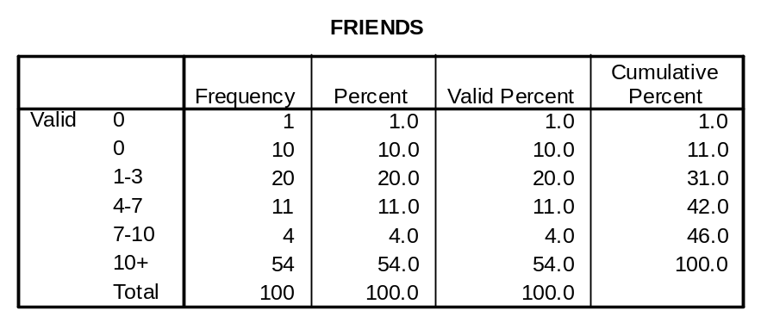
Concerning social trust, respondents were asked the following questions: “do you agree that generally most (Congolese, South Africans, other foreigners) are trustworthy?” and “If you drop a wallet in your neighbourhood, do you expect people to give it back to you?”? Findings have showed that trust is a very scarce commodity in Congolese community living in Central Johannesburg. A very significant number of individuals remained undecided as to whether other people are trustworthy or not.

Table 4 Congolese immigrants’ interpersonal trust
‘Do you agree or not that (generally), most X are trustworthy?’
Options | Congolese | South-Africans | Ethnic group | Other foreigners | Housemates | Wallet question
Agree | 43% | 32% | 47% | 24% | 70% | 21%
Neither agree nor disagree | 19% | 23% | 27% | 27% | 17% | 17%
Disagree | 38% | 45% | 26% | 49% | 13% | 61%

Based on the sequence of agreement or disagreement to these six questions, a final measure of interpersonal trust has been worked out in terms of labels such as “very trusting”, “trusting”, “very distrusting”, “distrusting”, “neither trusting nor distrusting”.

Table 5 Aggregated measure of Interpersonal trust
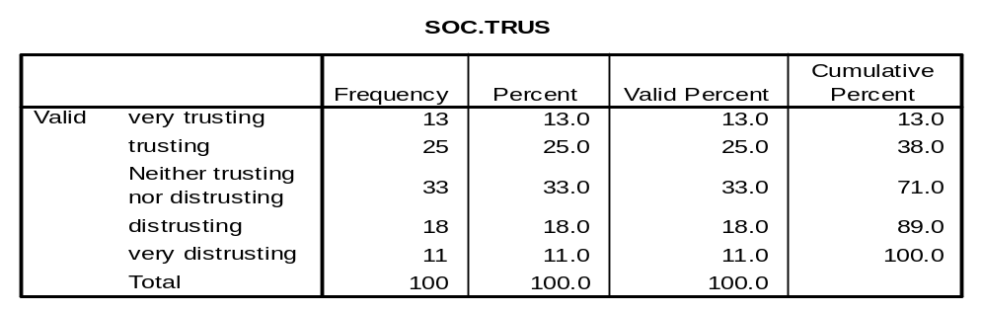
Finally, the level of trust towards the police appears to be high as illustrated by the table below.
Table 6 trust towards the police
Options | If you have knowledge of a crime, would you report it to the police? | If you have experienced robbery, would you report it to the police?
Yes | 80% | 77%
No | 20% | 23%

Both indicators are combined under a single value of political trust. Positive answer to both questions leads to labelling the respondent as “very trusting”. Those who have responded “No” to both questions are considered “very distrusting”, and the ‘yes and no’ responses correspond to the label “trusting”.

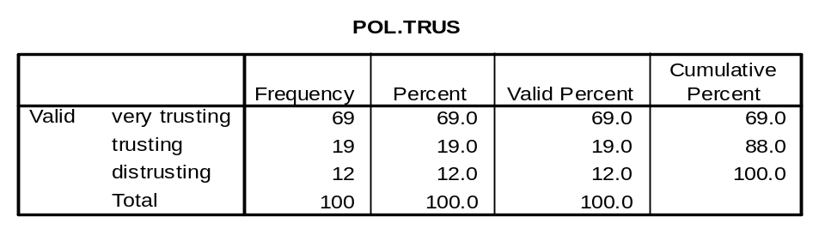
Table 7 Political trust

Following the logic outlined in table 1, a social capital index is worked out from variables as diverse as associational life, non-Congolese friendship, interpersonal trust and political trust. The final configuration of participants’ social capital is presented in the following table.

Table 8. Participants’ social capital
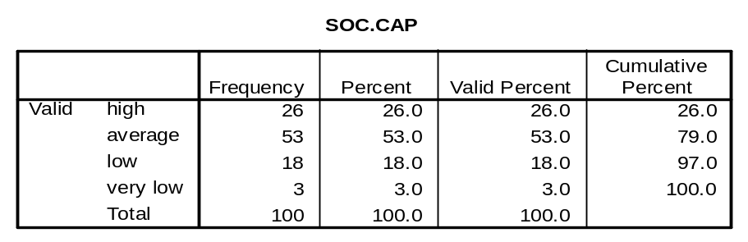

3.2. Participants’ economic performance
Five indicators of economic performance have been captured: employment experience, legal residence change, income variation, whether or not participants send money home, whether or not participants feel better off at the time of the interview than at arrival from Congo.
The configuration of participants’ initial and current employment, legal residence and monthly income status is outlined in table 11 while table 12 categorizes individuals’ economic experience in terms “progress”, “decline”, “constant” or “unclear”.

Table 9 Initial and current employment, legal residence and monthly income status
Options | Employment |  | Legal residence |  | Monthly income
 | Initial | Current | Initial | Current | Initial | Current
1 |  | 14 | 69 | 71 | 30 | 8
2 |  | 4 | 10 | 2 | 37 | 33
3 |  | 33 | 3 | 6 | 25 | 33
4 |  | 4 | 1 | 5 | 4 | 18
5 |  | 23 | 0 | 5 | 2 | 5
6 |  | 10 | 17 | 11 | 2 | 3
7 |  | 10 | N/A | N/A | N/A | N/A
8 |  | 2 | N/A | N/A | N/A | N/A
Employment options: (1)unemployed, (2)working part-time in formal sector, (3)working full-time in formal sector, (4)working part-time in informal sector, (5)working full-time in informal sector, (6)self-employed students, (7)Student, (8) Housewife or homemaker.
Legal residence options: (1)refugee permit, (2)study visa, (3)job visa, (4)permanent residence visa , (5)South African citizenship, (6)other.
Monthly income options : (1)R0 – R200, (2)R201 – R1000, (3)R1001-R3000, (4)R3001-9000, (5)R9001-R20000, (6)+R20000

Table 10. Participants’ economic experience

Options | Employment | Legal residence | Monthly income
Progress | 56 | 14 | 56
Decline | 2 | 0 | 2
Constant(statu quo) | 34 | 77 | 42
Unclear | 8 | 9 | 0

3.3. Correlation between social capital and economic performance
Does Congolese immigrants’ stock of social capital impact on their economic performance? The statistical association between participants’ social capital and their income variation is significant as the Pearson Chi-square appears to be inferior to 0.05(See table 13). As a heuristic tool for exploring the explanatory factors of income variation, multivariate regression analysis affirms the significance of a model including four social capital components. The model holds 20% explanatory power and identification with Congolese community, political trust and time spent in South Africa count among the significant predictors (see table 14). As one looks for explanatory factors for variation in legal residence, multivariate regression results display the validity of the model that includes social capital components, but point to the time spent in South Africa (Howlong) as the best predictor of variation in legal residence status. Only 19% of variation in legal residence can be explained by the model (see Table 15). Finally, a set of six questions aimed at capturing the contribution of various social networks in providing for key services in an immigrant’s daily experience, underscores the primacy of family and friend networks (see Table 16).

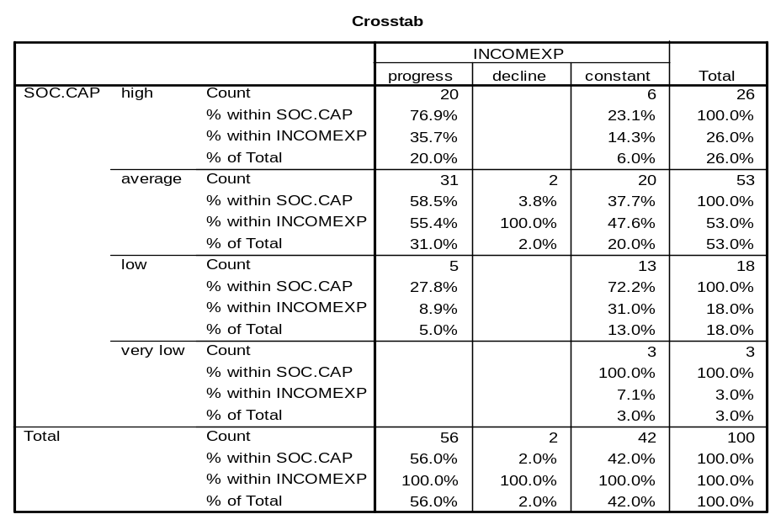
Table 11 Social capital and income experience
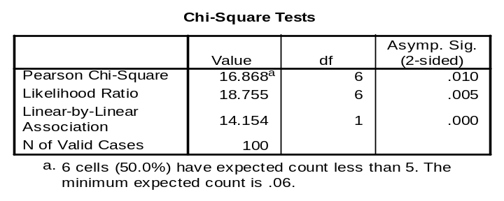
Table 12 Multivariate regression analysis: explaining variation in income experience

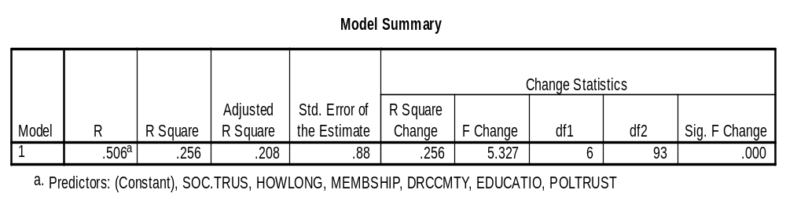
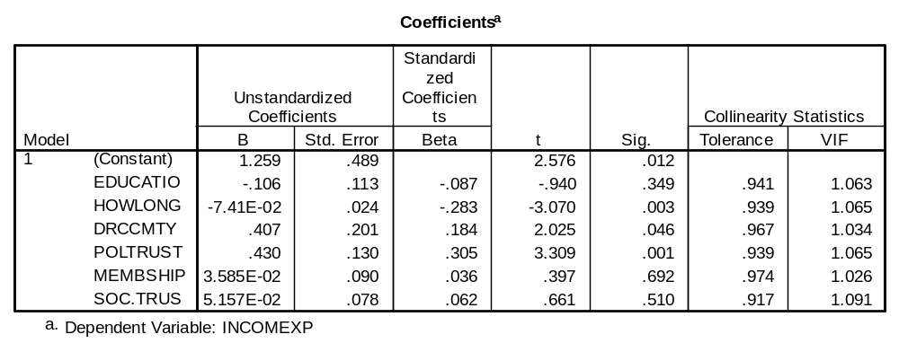
Table 13 Multivariate regression analysis: explaining variation in legal residence status

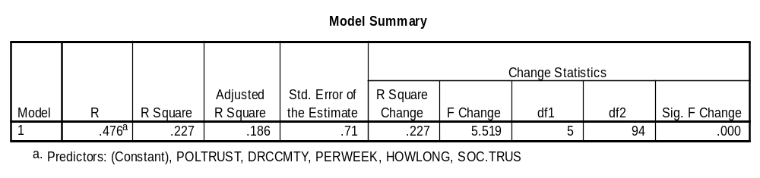
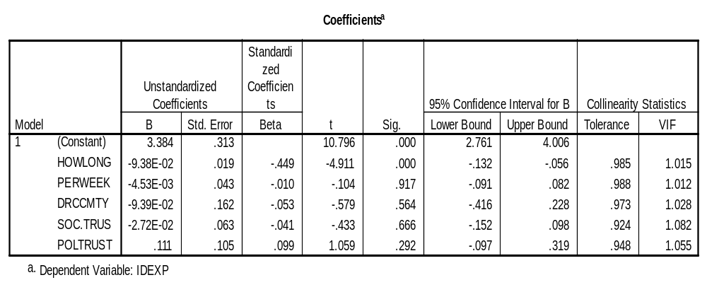

Table 14 Enabling factors in daily experience

Options | Travel to SA | Accommodation | Legal  Residence | Job | In  extreme | Help  The most | Average
Friend | 13% | 39% | 30% | 35% | 31% | 33% | 32%
Family | 29% | 41% | 30% | 15% | 38% | 42% | 31%
Myself | 36% | 13% | 27% | 10% |  |  | 22%
No one |  |  |  |  | 11% | 10% | 10,5%
God |  |  |  | 2% | 6% | 6% | 4,6%
Church |  | 4% | 3% | 2% | 5% | 4% | 3,5%
Bank |  |  |  |  | 2% |  | 2%
Work | 1% |  | 4% |  | 2% |  | 2,3%
University |  |  | 1% | 3% |  |  | 2%
Consultant |  | 2% | 1% | 2% | 1% |  | 1,5%
Other | 12%
N/A |  |  |  | 28%

4. Discussing the results

The case study of Congolese immigrants in Central Johannesburg supports the thesis according to which social capital positively contributes to economic performance. However, the study has also shown the weak predictive power of the model. Many other factors influence individual progress in income as well as in legal residence status. How long one has resided in South Africa has proved to be the best predictor of improvement in legal residence (see table 13) and the second best predictor of income progress (see table 12).
Yet, the fecundity of social capital is very limited in the experience of Congolese immigrants living in Central Johannesburg. A great number of participants of considerable level of social capital paradoxically suffer from economic stagnation or decline (see table 11). Besides, the majority of Congolese immigrants fall within the low income class as demonstrated by the table 9. Despite the positive influence of social networks on economic performance, the contrast between the depth of social capital and the precarious economic performance points to some degree of social capital powerlessness.
To account for such inefficiency of social networks, Edwards’ and Foley’s remarks are highly illuminating. They have argued that the “use value” of one’s social networks is a function not only of their size and vibrancy but most importantly of the broader socio-economic context, of the features of the networks, of individuals’ position in the network, of available resources, of the accessibility of resources and individual agency (Edwards and Foley, 1999). It appears that, at each of these aspects, Congolese immigrants’ social networks suffer from constraints that undermine their full productivity. South Africa immigration policies make legal immigration only affordable to a few. Most of Congolese immigrants then resort to the less costly asylum seeker permit that comes with unpleasantness of endless renewals and lack of any socio-economic support. South Africa’s tertiary institutions are hardly accessible as fees, required in one upfront payment, exclude the majority of prospective students. On the employment front, foreigners stand slim chance to join the mainstream workplace. Most of them get peripheral and undesirable jobs. All these constraints operate in an environment highly stressed by high rate of criminality, xenophobia, racism and racial segmentations. Other researchers have revealed similar mechanisms of “social exclusion” structurally enforced by State institutions and the civil society ( Vawda 1999; Hunter & Skinner 2002; Ballard 2003; Gotz 2003; Amisi 2005, 2006).
Factors intrinsic to Congolese associational life also contribute to the disempowerment of members. The predominance of religious associations, labelled “Pentecostal churches” or “Eglises de reveil” generally known as socio-economically unproductive, explains the absence of any commitment to the socio-economic upliftment of members. Friends and family based informal social solidarity may help in emergencies, but does not foster long-term solutions to problems facing Congolese immigrants. The main drawback with religious, informal and family networks lies in their lack of necessary resources. “Bridging” ties, civil associations, and formal organization support have greater potentials to link to unexpected and crucial opportunities (Putnam 2000). Congolese immigrants’ individual position within social networks also gets weakened by deficiencies such as lack of relevant skills and English proficiency.
This case study also challenges the dominant conceptualization of social capital popularized by the work of Putnam. Firstly, voluntary associations may not be the most important incubator of social capital for low-income immigrant communities. Family members and friends, in the case of Congolese immigrants, are the most crucial providers of capital. They constitute the kind of social networks that are easier to turn into effective capital. In this context, measuring individuals’ social capital solely on the basis of their involvement in associations as Putnam often does may be misleading. Voluntary associations may be attended only for symbolic purposes and not because they produce a tangible socio-economic gain. When it comes to addressing concrete daily problems, individuals resort to other social structures such as family members or close friends. Distinction between “symbolic” voluntary associations and “effective” family and friends’ social networks is important when one wants to account for individuals’ social capital. Secondly, Congolese immigrants’ social capital powerlessness illustrates that social capital is a function not only of social interactions but also of broad institutional context. The most connected individual may stagnate in poverty not because he lacks social networks, but because his social connections are of little “use value” and most importantly because macro institutional norms impose limitations on what those social networks can deliver. Lastly, the case study of Congolese immigrants’ religious associational life has raised scepticism on religious groupings capacity to advance members’ economic prospects. Whether such limitations emerge from structural or contextual features of religious associational life requires further investigation.
Are patterns of associational life found among Congolese immigrants in Central Johannesburg also replicable in any other Congolese immigrants’ communities in South Africa? As far as associational life is concerned, religious, hierarchical, and “bonding” ties are very likely to predominate in any Congolese immigrants’ community since these features are class-independent. Amisi and Ballard have found in the Durban Congolese refugee community prevalence of ethnic groupings rather than religious associations as this is the case in Johannesburg (Amisi & Ballard 2005). On these researchers’ account, ethnicity is so salient in the Durban Congolese community than religious associational life is seen as “linked to ethnicity, in that ethnicity of the pastor determines the ethnicity of the congregation” (Amisi & Ballard 2005). Such predominance of ethnic ties is not experienced in the Johannesburg Congolese immigrants’ community. Besides, in multi-class Congolese immigrants’ communities or in areas with predominance of low income individuals such as Central Johannesburg Congolese immigrants’ community, the influence of social capital on economic performance will tend to be weak, and informal networks as well as family members will tend to be the primary socio-economic support system. Amisi has found the same type of informal friends and family networks to be “a key component of the survival strategy of Congolese in Durban” (Amisi 2006). Whether such characteristics can be found in wealthy Congolese immigrants’ communities such as the Sandton Congolese community will require further research.
Would these characteristics of Congolese associational life be found in other African immigrants’ communities in South Africa? It is expected that these communities would also display features such as predominance of “bonding” interactions over “bridging” social capital, over-reliance on informal networks, primary support from friends and family members, distrust of out-group members, and weak contribution of social interactions to economic progress. The South Africa context affects African immigrants in similar ways notwithstanding few differences. That is why some consequences of and reactions to South African institutional constraints will be similar across African immigrants’ communities. Nevertheless, finding out whether other African communities also display prevalence of religious groupings requires additional enquiry.
In most immigrants’ communities throughout the world, in-groups interactions tend to be more intensive. This is reflected by a type of spatial occupation which favours the creation of identity homogeneous neighbourhoods. Lots of commercial opportunities and job recruitment flow within such “bonding” ties. What seems specific to Congolese associational life is the excessive multiplication of religious associations and the little impact of associational life on economic performance. The un-productivity of Congolese social capital may be circumstantial given that the Congolese Diaspora in South Africa is still very young. Organisation and social integration comes with time as the history of immigrant communities in America and in South Africa may teach us. Successful immigrant communities such as Jewish, Indians, Chinese etc have taken years to emerge as a viable social force.

Conclusion

This paper has firstly focused on measuring Congolese immigrants’ social capital following a psycho-structural definition of this concept. Drawing on a quantitatively designed survey conducted on a relatively random sample of Congolese immigrants living in Central Johannesburg, the study has documented vibrant associational life both in terms the number of organisations and the actual attendance of members. Informal networks within and outside the Congolese community have also been found operational. It has appeared that Congolese immigrants’ associational life, while largely diversified, is dominantly religious and homogeneous. Secondly, on the basis of participants’ employment experience, legal residence experience and income variation, this study has showed that Congolese immigrants undergo relative economic progress even as the majority of them still fall within the low income range, the less rewarding employment profile and the most precarious legal residence status. The paper has ultimately investigated mainly by statistical tools the correlation between the two variables as well as the impact of social capital on economic performance. While statistical analysis supports the widely accepted thesis on the positive influence of social capital on economic performance, weak prediction power of social capital components calls for contextual understanding of this relationship and points to other important context-specific dynamics and factors that explain why social networks have only limited economic impact on Congolese immigrants in Central Johannesburg.

Central Johannesburg in this study refers to the following areas: Yeoville, Berea, Hillbrow, Braamfontein, Parktown.
In line with Robert Putnam, Bourdieu and Coleman influential work on social capital, this paper takes both a socio-psychological and socio-structural conceptualization of social capital. It is understood both as “features of social organization, such as trust, norms, and networks, which can improve the efficiency of society by facilitating coordinated actions” (Putnam, 1993:167) and as “the aggregate of the actual or potential resources which are linked to possession of a durable network of more or less institutionalized relationships of mutual acquaintance and recognition –or in other words, to membership in a group- which provides each of its members with the backing of the collectivity-owned capital, a “credential” which entitles them to credit, in the various senses of the word” (Bourdieu,1986:248-249).
The sample reflects the age and gender composition that one would experience in everyday interactions in Congolese immigrants’ meeting places. Independent research conducted within the same area in 2003 by the department of forced migration of the University of the Witwatersrand displays similar demographic characteristics. Out of 106 Congolese participants, 74,6% were male, and 25,5% female. The following age composition appears in the research report: 18-25(30.8%), 26-30(33.7%), 31-35(17.3%), 36-40(11.5%, 41-45(3.8%), 46-50(2.9%), 51+(0.0%)(Human displacement, survival, and the politics of space. Final survey results, 19 June 2003, p.2)
Employment options have included: (1) unemployed, (2) working part-time in formal sector, (3) working full-time in formal sector, (4) working part-time in informal sector, (5)working full-time in informal sector, (6)self-employed students, (7)Student, (8) Housewife or homemaker. Progress (1) has been inferred in the following cases: 1-2, 1-3, 1-4, 1-5, 1-6, and 1-7. Decline (2) has been inferred in cases: 4-1, 3-1. There have been few constant (3) cases: 4-6, 5-3, 1-1, 2-2, 3-3, 4-4, 5-5, 6-6, 7-7, and 8-8. Some employment trajectories are not easy to categorize (4): 7-4, 3-2, 7-1, 5-7, 7-8, 3-7, and 5-8. Each couple indicates the type of occupation at arrival from Congo and at the time of the survey. Only cases where progress or decline is clear have been characterized as such. Such approach has some limitations: there may be progress or decline even within the same category of employment situation. Capturing such details would have required further inquiry. As for legal residence, this study does not differentiate between individuals holding a refugee permit and those still having the asylum seeker permit. These have been the options: (1) refugee permit, (2) study visa, (3) job visa, (4) permanent residence visa, (5) South African citizenship, (6) other. Progress (1) has been inferred in the following cases: 1-4, 1-3, 1-4, 1-5, 5-3, 2-5, 2-3, 2-4, 6-3, 6-1, 6-4. There have been no instances to describe as decline (2). Constant (3) cases are most common: 1-1, 6-6. Some legal residence trajectories are not easy to categorize (4): 2-1, 1-6. Shifting from other (6) to any other category has been described as ‘progress’ since it has generally meant that the person did not have any legal residence permit.
1) very trusting : 5 to 6 agreements; 2) trusting: 3 to 4 agreements; 3) very distrusting: 5 to 6 disagreements; 4) distrusting: 3 to 4 disagreements; 5) neither trusting nor distrusting: any other combination.
The Pearson Chi-Square test examines whether an association between two variables is due to chance (which would mean there is no relationship between the independent and dependent variables), when taking sampling errors into account. This assumption is called null hypothesis. In case the probability value of the test ( Asymp.Sig.) is inferior to .05, the null hypothesis is to be rejected (http://www.georgetown.edu/departments/psychology/researchmethods/statistics/inferential/chisquareone.htm)
The interpretation of regression analysis tables has been facilitated by sources such as the following online Statistics course : http://www2.chass.ncsu.edu/garson/PA765/regressa.htm
Participants were asked whether or not they considered themselves as part of the Congolese community.
Participants were asked: 1) who influenced you the most to come to South Africa? 2) Who provided you with accommodation at your first days in Johannesburg? 3) Who helped you to get legal residence from the department of home affairs? 4) Who helped you to find a job if applicable? 5) In extreme situations, who would you speak to as a last resort? 6) when you look at your stay in South Africa, who has helped you the most?
Cfr L’Economie des Eglises de reveil et le developpement durable en RDC, Facultes Catholiques de Kinshasa, 2003.
In analyzing social networks and their consequences, Putnam finds of utmost importance the distinction between bridging (inclusive) and bonding (or exclusive) networks. Bonding social networks are, by choice or necessity, “inward looking and tend to reinforce exclusive identities and homogeneous groups”. On the other hand, bridging social networks are, by choice or necessity, “outward looking and encompass people across diverse social cleavages”. (Putnam 2000:22)

